horizontal line

Tool Manager

Last updated by Martin Lee:

2024-03-13

# OVERVIEW

Ever since our local tools got wiped out last time, this presents an ideal opportunity to create a shelf that every artist can manage independently. Not only can it store personal projects or tools under testing, but it also allows individuals to arrange and prune as needed. Additionally, in alignment with our previous discussion regarding the tool list storage issue, to avoid occupying too much of Maya's interface space, we could prioritize using a menu for this toolbar.

This tool will create a custom menu with a tool managing ui for users to input their own tools.

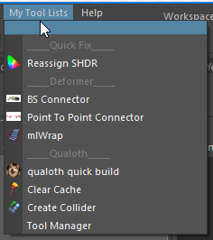

# 

# 

# SETUP

### For SFN Department,

1. Under our Tech_Anim shelf, we have a Setting tool and open it.

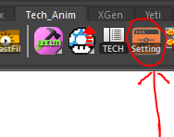

1. After opening it, turn on two switches (**Add Tech Anim Script to sys.path**, **User Startup Script**) and add the following script in the script editor.

import menu_editor.menu_builder as mmb

reload(mmb)



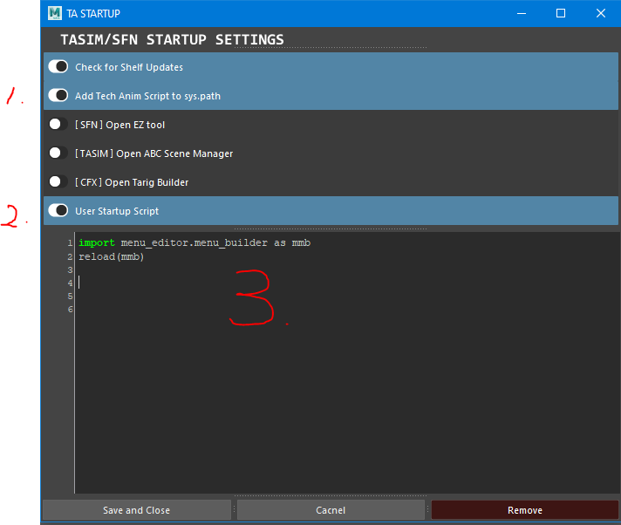

1. Hit **Save and Close**.
2. After setup, now we can see our **My Tool Lists** on top of the menu bar next or near to **Help** every time when we open maya.



### 

### 

### 

### 

### 

### For Others,

There are two ways to set this up.

#### (1)Copy and paste it from reference folder,

1. Open these folders from these paths.

C:\Users\yourUserName\Documents\maya

1. If you don’t have these two files userSetup.py and tool_manager_setup.py, you can either create it or copy from Here.

G:\Tech_Animation\preference\martinle\menu_setup_files

#### (2)Or creating it by yourself,

1. If you already have these files in your folder, or create it by yourself, then open it and add these lines of code.



import maya.cmds as cmds

import os

current_file_path = os.path.dirname(os.path.abspath(__file__))

cmds.evalDeferred("execfile('{}/tool_manager_setup.py')".format(current_file_path))

 

import sys

if 'G:/Tech_Animation/scripts' not in sys.path:sys.path.append('G:/Tech_Animation/scripts')

from pynasty import *

import menu_editor.menu_builder as mmb

reload(mmb)

After setup, now we can see our **My Tool Lists** on top of the menu bar next or near to **Help** every time when we open maya.



# 

# 

# 

# 

# 

# 

# 

# 

# 

# 

# 

# 

# TOOL MANAGER

When we first open the menu, we will only get a simple option **Tool Manager**, we can organize our tools with this helper.





Tool Manager UI

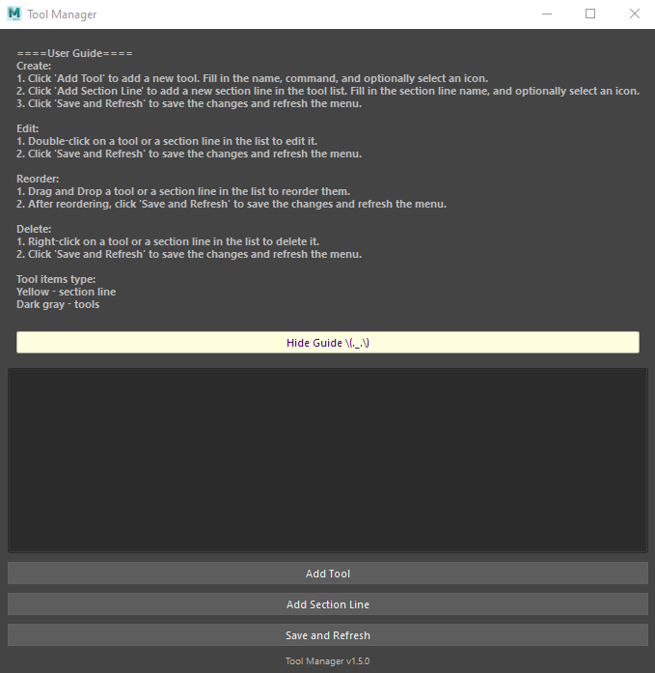

## ITEM TYPES

1. Yellow - section line
2. Dark gray - tools

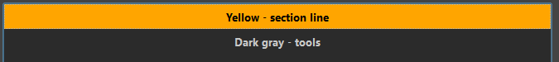

## CREATE

### Add tool

1. Click '**Add Tool**' to add a new tool. Fill in the name, command, and optionally select an icon, after that you can hit **Save and Refresh** to see your tool appear in the menu.



### 

### Add section line

1. Click 'Add Section Line' to add a new section line in the tool list. Fill in the section line name, and optionally select an icon. After that you can hit **Save and Refresh** to see your tool appear in the menu.



## 

## 

## 

## DELETE

1. **Right-click** on a tool or a section line in the list to delete it.
2. Click **'Save and Refresh'** to save the changes and refresh the menu.



## 

## 

## 

## EDIT

### Edit existed tool

1. Double-click on a tool or a section line in the list to edit it.
2. Click 'Save and Refresh' to save the changes and refresh the menu.



### 

### 

### Reorder tool list

1. We can use drag and drop to reorder our tool list.



## 

## 

## 

## 

## 

## SAVE & REFRESH

1. Remember to hit the **Save and Refresh** button after your operation and before you close the **Tool Manager**!!! Or else it won’t save to your menu!

